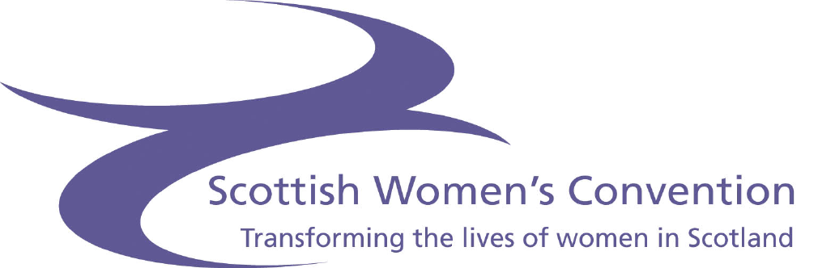

The Scottish Women’s Convention (SWC) would like to invite you, and any other women you know to attend the following SWC consultation events:

Where | Venue | Time | Date
Rothesay | The Pavilion  Argyle Street  Rothesay  Isle of Bute | 12 Noon – 4pm | 25th July
Dunoon | Esplanade Hotel  West Bay  Dunoon | 12 Noon – 4pm | 26th July
Ullapool | Harbour Lights Hotel  Garve Road  Ullapool | 10.30am – 2.30pm | 17th August
Stornoway | Caladh Inn  9 James Street  Stornoway  Isle of Lewis | 12 Noon – 4pm | 20th August
Perth | Queens Hotel  Leonard Street  Perth | 12 Noon – 4pm | 9th October
Dundee | Hilton Hotel  Earl Grey Place  Dundee | 12Noon – 4pm | 10th October

The events will be very informal with a free lunch provided. It will provide women in your area with an opportunity to meet the Scottish Women’s Convention and discuss key issues of concern and how you would like to see things change for you and your families.

It is vitally important that women have an opportunity to engage and participate in policy development. This will ensure Scotland’s policy makers take women’s views into account in areas such as:

- employment
- childcare
- health
- education
- tackling violence against women
- public transport
- pensions

The SWC therefore aims to talk to women throughout Scotland this year to hear your views, concerns and ideas. The SWC will then take this information to the Scottish Executive, Scottish Ministers and other relevant organisations, such as the Equal Opportunities Commission (EOC) and the Commission for Equality and Human Rights (CEHR).

The SWC also invites women to participate in events such as International Women’s Day and our Education Day for women on the 6th September 2007, which will provide women with the information and tools to apply for positions in public bodies, councils and posts in the local community.

Please register for any of the consultation events by filling in and sending the attached form to:

Scottish Women’s Convention

26 Albany Street, (basement)

Edinburgh

EH1 3QH
or email mary@scottishwomensconvention.org
or give us a call at the SWC office on 0131 557 8950.

Let your friends know about this event and ask them to come along too. Just ask them to give us a call to let us know, so we have the right numbers for catering.

Best wishes

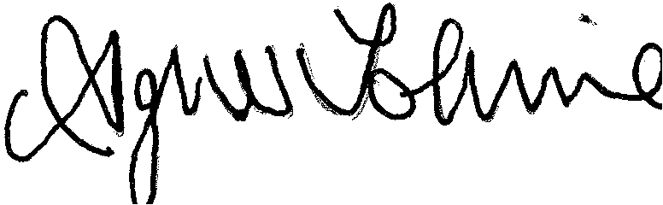

Agnes Tolmie
Chairperson

SWC Roadshow
Registration Form

Please indicate by ticking in the relevant box below which event you wish to attend:

Rothesay  25 July | Dunoon  26 July | Ullapool  17 August | Stornoway  20 August | Perth  9 October | Dundee  10 October

Please print clearly
Full Name: ________________________________________

Contact Address: ________________________________________
(Please include postcode &
organisation, if applicable) ___________________________________________

________________________________________

________________________________________
Telephone No: ____________________________________________

Email: ____________________________________________

Do you have any access requirements? Yes No
Please give details.

Confirmation letters will be posted to you approx 3 weeks prior to the event.

