
Why Branch members should vote YES to retain UNISON's Political Fund

Don't silence your union!

Shortly after 9 February you will receive a ballot paper looking a bit like this.
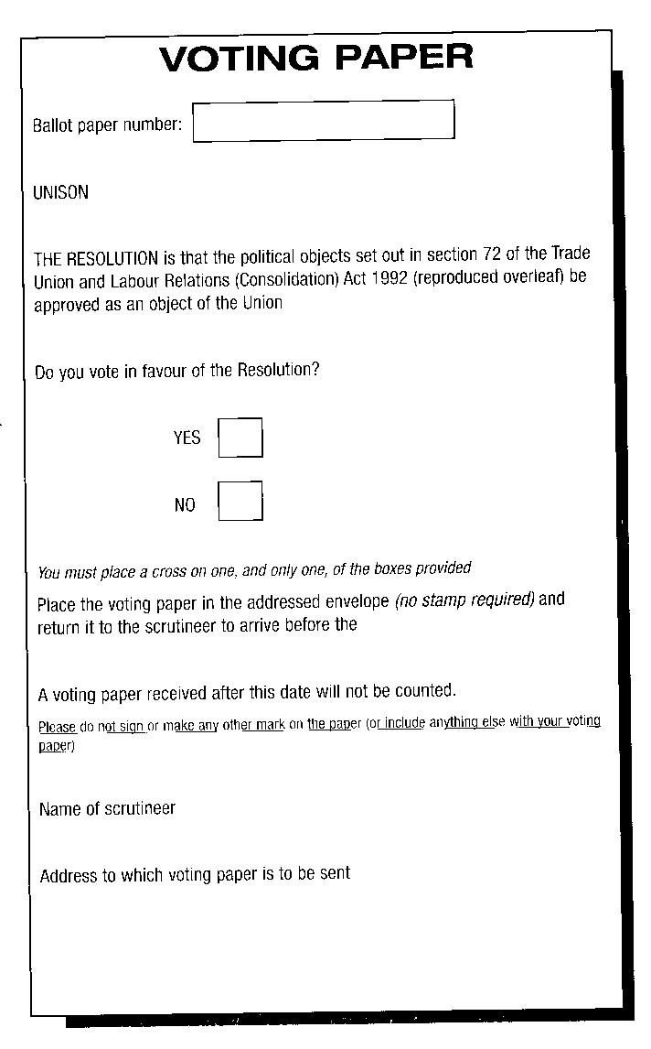

This is a ballot paper asking you if you are in favour of retaining UNISON's unique Political Fund. Every 10 years UNISON is legally bound to do this and the Branch is strongly urging you to vote YES in this ballot.

Unique campaigning fund
UNISON's Political Fund is unique in the British Trade Union movement, and is the resource behind many successful and very public campaigns on behalf of UNISON members.


Scottish Secretary Matt Smith says “The Political Fund gives UNISON a voice. It allows us to speak up for UNISON members during election campaigns and in the political discussions when decisions are being made. In Scotland it has allowed us to fight against a centralised correctional agency and for better protection for members at risk from violent attack. It has continually resourced work exposing the economic madness that is PFI and allowed us to campaign to stop the evil of racism.”
What use is the Political Fund?
Dave Watson, UNISON's Scottish Organiser for Policy and Information points out that UNISON's twin-track funds allows us to argue members' case in a variety of fora.

“Issues like the recent victory against the single correctional agency, for example were financed from both funds.” He said “The public material and political campaigning at party conferences was financed from the GPF, whilst the briefings and lobbying of Labour MSPs and ministers was backed by the Labour Link. The best of both worlds in putting across UNISON members’ views.”

Not about affiliation
You may think that this is all about Labour Party affiliation, but UNISON’s unique arrangement makes sure that this isn't the case. Mike Kirby, UNISON’s Scottish Convenor, explains. “UNISON’s political fund has two sections that give every member a choice. Members can pay into either the General Fund or to Labour Link - or indeed into neither or both.” He said “To continue giving members that choice, members should vote YES.”

In a union whose members mainly work for public services, and whose job, pay and pensions are subject to political decisions every day, a no vote would fatally undermine the ability of UNISON to fight for you on issues like defending decent pensions.

Other issues the Political Fund has campaigned on
■ Against PFI and the two-tier workforce
■ For maternity rights for trainee nurses and midwives
■ For our Scottish Parliament
■ For Equal Pay in Scotland and the UK
■ Against water privatisation,
■ For rights to breastfeed in public,
■ Against assaults on staff,
■ For clean air in public workplaces
■ Against the BNP

Vote Yes yourself and get your colleagues to do the same.
Ballot arrangements
Ballot papers will be despatched from 9 - 11 Feb. They will be posted to your home address. All members should get one.

If you haven't received yours by 21 Feb, phone UNISON direct on 0845 355 0845 (06.00-24.00 Mon-Fri; 09.00 - 16.00 Sat).

They must be sent back in the pre-paid envelope. They must reach the independent scrutineer by 11 March.

